**Assignment 4**

**Travel Agency**

* **Requirement Gathering :**

My friend Shradaya Ramtel provided me with the requirements as follow:

**Request for proposal**

|  |  |  |
| --- | --- | --- |
| RFP: **Travel Agency** | Proposal Due By: **09/20/2021** | **Manakamana Travel Agency** |
| **Project Overview:**  Our company Manakamana Travel Agency is willing to build a system in order to make it easy for us to communicate well with our customers. We have a number of travel plans and the customers can select a travel plan and plan their trip ahead. | | |
| **Project Goals:**   * Make Bookings * Make Payments * Add new travel packages * Add new travel locations * Add new means of transport | | |
| **Scope of Work:**  We would like the system that allows the general users to view the different available packages, make bookings for the packages, and make payments for their travel; while the employees have the ability to make changes in packages, locations and means of transport. The information regarding the past bookings, payments and expired packages should also be stored. | | |
| **Current Roadblocks and Barriers to Success**   * No proper data management * No area for staffs only admin area * No proper way to get full information about packages * Poor payment management | | |
| **Submission Requirements**   * Need a fully functional system * Must be able to handle hundreds of users at once * Abundant storage | | |
| Project Due By: **November 2021** | | Budget: **$20000** |
| Contact: **Shradaya Ramtel** | Email: **Shradays@gmail.com** | Phone #: **9865737373** |

**Analyzing and drafting requirements**

* Packages are listed with location of visit,hotel, transport and cost
* Packages history be maintained regarding expiry or ongoing
* Customer can book the packages
* Payment can be done through application
* Customer History be maintained
* Employee can modify packages, locations, hotel, transport info
* Admin has overall access
* **Conceptual Modeling**

1. Identifying Entities:

package - package_id, name, start_date, end_date, description, cost,status

destination - destination_id, location_name,package_id

hotel - hotel_id, name, location, cost,package_id

transport - transport_id, type, cost,package _id

customer - customer_id, name, age, phone, email

booking - booking_id, date , customer_id

payment - payment_id, type, amount

customer_history - ch_id, customer_id, date, package_id,payment_id

employee - employee_id, name,age, phone, email

2. Defining Business Rules:

* Contains three groups : Customer, Employee, Admin
* Packages are listed with location of visit,hotel, transport and cost
* Packages history be maintained regarding expiry or ongoing
* Customer can book the packages
* Payment can be done through application
* Customer History be maintained
* Employee can modify packages, locations, hotel, transport info
* Admin has overall access

3. Conceptual Model

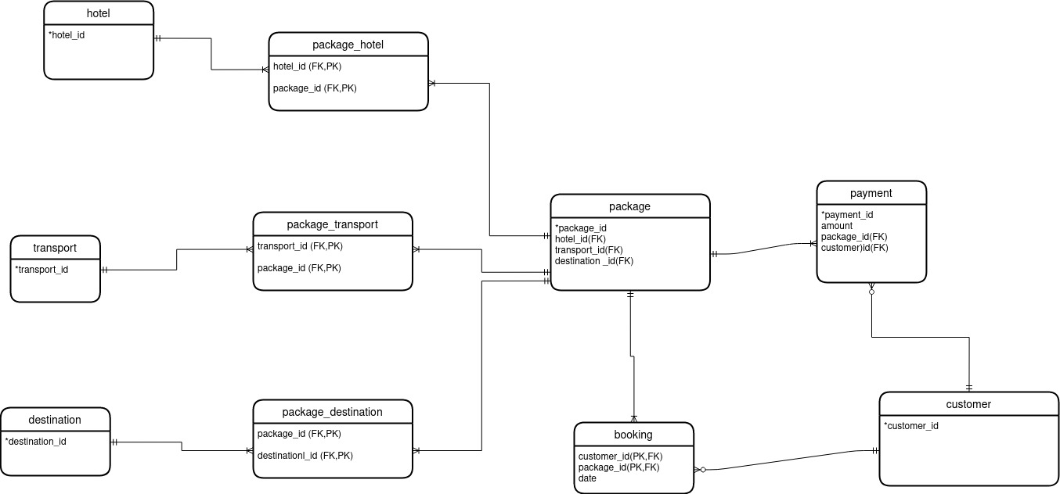

**Normalization:**

e.g. Package table

|  |  |  |  |  |  |  |  |  |
| --- | --- | --- | --- | --- | --- | --- | --- | --- |
| package_id | name | destination_id | destination | hotel_id | hotel |  | transport_id | transport |

|  |  |  |  |  |
| --- | --- | --- | --- | --- |
| package_id | name | destination_id | hotel_id | transport_id |

|  |  |
| --- | --- |
| hotel_id | hotel |

|  |  |
| --- | --- |
| destination_id | destination |

**Functional Dependencies :**

package_id -> name, destination, transport , hotel

package_id, hotel_id -> hotel

hotel_id -> hotel

package_id -> hotel_id -> hotel

* **Logical Modeling**

1. Identifying attributes and domains for entities and relationships:

|  |  |  |
| --- | --- | --- |
| **Entity** | **Description** | **Domain** |
| **package** | packages containing information about travel |  |
| Attributes:  package_id  name  start_date  end_date  description  cost  status  hotel  destination  transport | Identifier for entity, SK, PK  Name of package  Date of start  Date of end  Info About package  Price for the package plan  active/inactive status  Hotel Code(FK)  Destination Code(FK)  Transport Code(FK) | Auto Generated  Text  Date  Date  Text  Number  Boolean Value  Valid id from hotel table  Valid id from destination table  Valid id from transport table |
| **hotel** | Hotel information |  |
| Attributes:  hotel_id  name  description  location  cost | Identifier for entity, SK, PK  Name of Hotel  About Hotel  Hotel Location  Cost for hotel | Auto Generated  Text  Text  Valid id from city table  Number |
| **package_hotel** | Relationship between packages and hotels |  |
| Attributes:  package_id  hotel_id | Package Code(PK,FK)  Hotel Code (PK,FK) | Valid id from package table  Valid id from hotel table |
| **destination** | Location information |  |
| Attributes:  destination_id  location_name  description | Identifier for entity, SK, PK  Location Name  About Location | Auto Generated  Text  Text |
| **package_destination** | Relation Between packages and destinations |  |
| Attributes:  package_id  destination_id | Package Code(PK,FK)  Destination Code (PK,FK) | Valid id from package table  Valid id from destination table |
| **transport** | Transport information |  |
| Attributes:  transport_id  type  cost | Identifier for entity, SK, PK  Transport ways(from air, from road)  Cost for transport | Auto Generated  Text  Number |
| **package_transport** | Relation between packages and transports |  |
| Attributes:  package_id  transport _id | Package Code(PK,FK)  Transport Code (PK,FK) | Valid id from package table  Valid id from transport table |
| **customer** | Users of application |  |
| Attributes:  customer_id  name  dob  phone  email  location | Identifier for entity, SK, PK  First name, Last name  Date of Birth  Can have one phone no.  Can have one email  Address | Auto Generated  Text  Date  Unique  Unique  Valid id from city table |
| **booking** | Booking info about customer and packages they book |  |
| Attributes:  customer_id  package_id  booking_date  package_status | Customer Code (PK,FK)  Package Code(PK,FK)  Date of booking  Can have active and expired package for history | Valid id from customer table  Valid id from package table  Valid Date  Boolean Value |
| **payment** | Payment details |  |
| Attributes:  payment_id  customer_id  package_id  type  date  amount | Identifier for entity, SK, PK  Customer Code(FK)  Package Code (FK)  Different Payment options  Date of Payment  Amount of pay | Auto Generated  Valid id from customer table  Valid id from package table  Text  Date  Valid Number |

2. Logical model

<https://drive.google.com/drive/folders/1BQbZpGRJ17VY9wNK3QT1x-xRBJT3DLnp>

* **Physical Model**

CREATE DATABASE travelagency;

-- Creating necessary tables from logical model

--hotel

CREATE TABLE hotel(

hotel_id serial PRIMARY KEY,

name VARCHAR(50),

location INT REFERENCES city(city_code),

description VARCHAR(150),

cost INT

);

--transport

CREATE TABLE transport(

transport_id serial PRIMARY KEY,

type VARCHAR(20),

cost INT

);

--destination

CREATE TABLE destination(

destination_id serial PRIMARY KEY,

location_name VARCHAR(50),

description VARCHAR(150)

);

-- package

CREATE TABLE package(

package_id serial PRIMARY KEY,

name VARCHAR(50),

start_date DATE,

end_date DATE,

description VARCHAR(150),

cost INT ,

active_status BOOLEAN,

hotel_id INT REFERENCES hotel(hotel_id),

transport_id INT REFERENCES transport(transport_id),

destination_id INT REFERENCES destination(destination_id)

);

--package_hotel

CREATE TABLE package_hotel(

hotel_id INT REFERENCES hotel(hotel_id),

package_id INT REFERENCES package(package_id),

unique(hotel_id, package_id)

);

--package_transport

CREATE TABLE package_transport(

transport_id INT REFERENCES transport(transport_id),

package_id INT REFERENCES package(package_id),

unique(transport_id,package_id)

);

--package_destination

CREATE TABLE package_destination(

destination_id INT REFERENCES destination(destination_id),

package_id INT REFERENCES package(package_id),

unique(destination_id,package_id)

);

--city

CREATE TABLE city(

city_code INT PRIMARY KEY,

city_name VARCHAR(50)

);

--customer

CREATE TABLE customer(

customer_id serial PRIMARY KEY,

name VARCHAR(50),

dob DATE ,

email VARCHAR(30) unique,

phone INT not null,

location INT REFERENCES city(city_code)

);

--booking

CREATE TABLE booking(

customer_id INT REFERENCES customer(customer_id),

package_id INT REFERENCES package(package_id),

booking_date DATE ,

package_status BOOLEAN

)

--payment

CREATE TABLE payment(

payment_id serial PRIMARY KEY,

customer_id INT REFERENCES customer(customer_id),

package_id INT REFERENCES package(package_id),

type VARCHAR(30),

payment_date DATE,

amount INT

);

* Other forms of normalization were done while physical modeling:

Like: Hotel Location, Customer location attributes were split into city table.

**Health Care**

* **Requirement Gathering :**

**Request for Proposal (RPF):**

An Online Health Care system should be made. It should consists the details of registered Clinics, Hospitals and Pharmacies with their provided services. Users can register as a Doctor, Patient , Clinic, Hospital or Pharmacy. The registered Doctors should be listed in the site along with registered clinics,hospitals and pharmacies. User can have appointment to clinic,hospital or doctor. There can also be consultation with doctor directly. The billing can be done through payment like esewa to registered clinic/hospital/doctor/pharmacies. There can also be Discussion section to write about the problems related to users.

**Collecting Information:**

When collecting information from key stakeholders, it is essential to focus on two main questions that should serve as guidelines for the overall requirements gathering process.

1. How can an this system contribute to your practice’s strategic goals?
2. What features are the best for achieving your practice’s strategic goals?

So, this may include meeting sample like:

Meeting Notes

Date: Sept 7, 2021

Agenda:

* Discussion about the proposed site.
* Cost finalization.
* Gathering info for design.

Meeting Notes:

1. User friendly site to be made.

Decision Made:

1. Project Accepted.
2. Design for site finalized.

Action Items:

Discovery Questions

|  |  |
| --- | --- |
| **Questions/ Thoughts** | **Answers** |
| Who will be using the new system? | It should be focused to give public a online health care options. So, the system is frequently used by patients , doctors, pharmacies and admin to update regarding new registered details or for removing existing details. |
| So the users can register using any of the options. But how will be the authenticity be done if the doctor/pharmacy/clinic registered directly ? So I recommend admin verify before these registration.. do you consider this ? | Yeah definitely, it would be better if the users are real and valid. So, that should be done. |
| What patient population are we documenting? (i.e., pediatrics, geriatrics, patients, etc.) | There can be different categories of patients obviously i.e pediatrics, geriatrics but all can be kept under patients. |
| Should the payment system be other than esewa? | Since esewa is popular, it should be used as a payment method. Other payments would be plus if they could be add`ed like khalti. |
| What database to use? | MySQL or Posgres, any! |
|  |  |

**Analyzing and drafting requirements**

After Analyzing , the entities may include:

* Hospitals , Clinics, Pharmacies,Doctor, Patients can be registered
* Services are provided by Hospitals, Clinics, Doctors
* Patient can appoint to Hospitals, Clinics, Doctors
* Patient can consult to specific Doctor
* Patient can give feedback to doctor
* Patient can open conversation in Discussion section
* Esewa or other payments be done by patients to hospital, pharmacies, doctors
* History is maintained for users
* Admin verifies Hospital, Clinic, Doctor and Pharmacy registration
* Admin can modify registered user details, payments and other features
* **Conceptual Modeling**

1. Identifying Entities:

clinic - clinic_id ,name,location

hospital - hospital_id, name, location

doctor - doctor_id, doctor_name, phone_no,qualification, specialization(service)

services - service_id, name ,cost

pharmacy - pharmacy_id,name, location

medicine - med_id, name, brand,cost

patient - patient_id , name, age, sex, address ,phone, blood_group

patient_history - disease_history , treatment

appointment - appointment_id , patient_id , date

consultation - c_id, doctor_id, date,patient_id

feedback - feedback_id, description,doctor_id, patient_id

discussion - p_id, description

billing - billing_id, amount , type

2. Defining business rules

* Hospitals , Clinics, Pharmacies,Doctor, Patients can be registered
* Services are provided by Hospitals, Clinics, Doctors
* Patient can appoint to Hospitals, Clinics, Doctors
* Patient can consult to specific Doctor
* Patient can give feedback to doctor
* Patient can open conversation in Discussion section
* Esewa or other payments be done by patients to hospital, pharmacies, doctors
* History is maintained for users
* Admin verifies Hospital, Clinic, Doctor and Pharmacy registration
* Admin can modify registered user details, payments and other features

3. Conceptual Model :

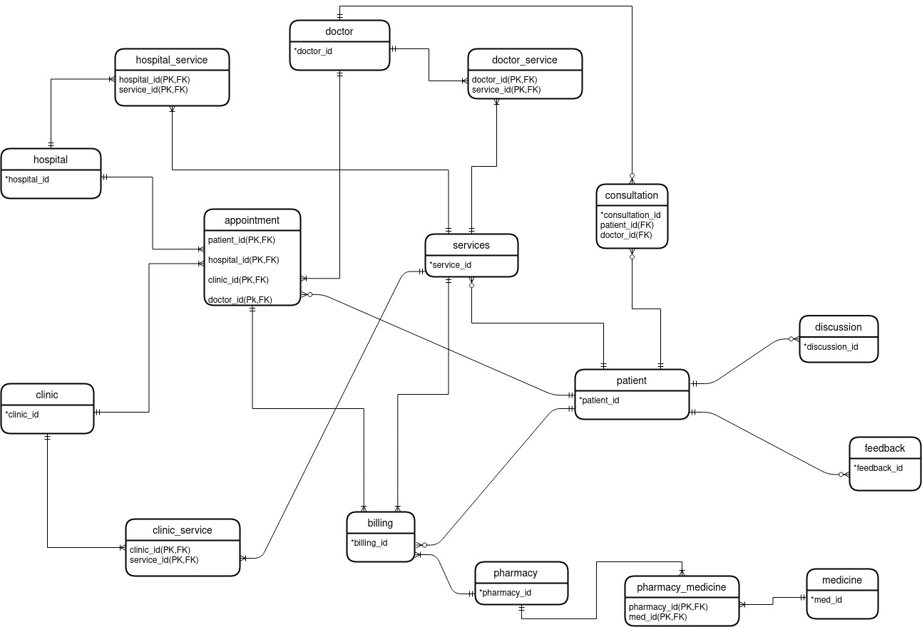

* **Logical Modeling**

1. Identifying attributes and domains for entities and relationships:

|  |  |  |
| --- | --- | --- |
| **Entity** | **Description** | **Domain** |
| **hospital** | Hospital information |  |
| Attributes:  hospital_id  name  location | Identifier for entity, SK, PK  Name of hospital  Location of hospital | Auto Generated  Text  Text |
| **clinic** | Clinic information |  |
| Attributes:  clinic_id  name  location | Identifier for entity, SK, PK  Name of clinic  Location of clinic | Auto Generated  Text  Text |
| **pharmacy** | Pharmacy information |  |
| Attributes:  pharmacy_id  name  location | Identifier for entity, SK, PK  Name of pharmacy  Location of pharmacy | Auto Generated  Text  Text |
| **doctor** | Doctor information |  |
| Attributes:  doctor_id  name  phone_no  qualification  specialization  service_id | Identifier for entity, SK, PK  Name of doctor  Valid phone no. of doctor  Qualification of doctor  Specialization info  Service Code (FK) | Auto Generated  Text  Number  Text  Text  Valid id from service table |
| **services** | Services provided for health care |  |
| Attributes:  service_id  name  cost  patient_id | Identifier for entity, SK, PK  Name of service  Price of service  Patient Code | Auto Generated  Text  Valid Number  Valid Code from patient table |
| **appointment** | Relation for patient appointments |  |
| Attributes:  patient_id  hospital_id  clinic_id  doctor_id  date | Patient Code (PK, FK)  Hospital Code (PK, FK)  Clinic Code(PK,FK)  Doctor Code(PK,FK)  Date of appointment | Valid patient id from patient table  Valid id from hospital table  Valid id from clinic table  Valid id from doctor table  Date |
| **patient** | Patient Details |  |
| Attributes:  patient_id  name  dob  phone_no  location  blood_group | Identifier for entity, SK, PK  Name of patient  Date of Birth  Valid Phone number  Address  Blood Group | Auto Generated  Text  Date  Number  Text  Text |
| **consultation** | Relation for consulting doctor |  |
| Attributes:  patient_id  doctor_id | Patient Code (PK,FK)  Doctor Code (PK,FK) | Valid id from patient table  Valid id from doctor table |
| feedback | Feedback give by patient to doctor |  |
| Attributes:  patient_id  doctor _id  description | Patient Code(PK,FK)  Doctor Code (PK,FK)  Description given by patient | Valid id from patient table  Valid id from doctor table  Text |
| **discussion** | Discussion about patient problems |  |
| Attributes:  patient_id  description | Patient Code(PK,FK)  Discussion opened by patient | Valid id from patient table  Text |
| **billing** | Payment Details |  |
| Attributes:  billing_id  type  amount | Identifier for entity, SK, PK  Type of pay  Valid amount | Auto Generated  Text  Number |
| **medicine** | Medicine Details |  |
| Attributes:  medicine_id  name  brand  cost | Identifier for entity, SK, PK  Name of medicine  Brand of medicine  Price of medicine |  |

2. Logical Mode:

<https://drive.google.com/drive/folders/1BQbZpGRJ17VY9wNK3QT1x-xRBJT3DLnp?usp=sharing>

* **Physical Model**

CREATE DATABASE healthcare;

-- Creating necessary TABLE from logical model

--city

CREATE TABLE city(

city_code INT PRIMARY KEY,

city_name VARCHAR(50)

);

--hospital

CREATE TABLE hospital(

hospital_id serial PRIMARY KEY,

name VARCHAR(50),

location INT REFERENCES city(city_code)

);

--clinic

CREATE TABLE clinic(

clinic_id serial PRIMARY KEY,

name VARCHAR(50),

location INT REFERENCES city(city_code)

);

--pharmacy

CREATE TABLE pharmacy(

pharmacy_id serial PRIMARY KEY,

pharmacy_name VARCHAR(50),

location INT REFERENCES city(city_code)

);

--medicine

CREATE TABLE medicine(

med_id serial PRIMARY KEY,

name VARCHAR(50),

brand VARCHAR(50),

cost INT

);

--services

CREATE TABLE services(

service_id serial PRIMARY KEY,

service_name VARCHAR(50),

cost INT

);

--specialization

CREATE TABLE specialization(

specialization_id serial PRIMARY KEY,

specialization_name VARCHAR(50)

);

--doctor

CREATE TABLE doctor(

doctor_id serial PRIMARY KEY,

name VARCHAR(50),

phone_no INT unique,

qualification VARCHAR(50),

specialization INT REFERENCES specialization(specialization_id),

service_id INT REFERENCES services(service_id)

);

--patient

CREATE TABLE patient(

patient_id serial PRIMARY KEY,

name VARCHAR(50),

dob DATE,

phone INT unique,

location INT REFERENCES city(city_code),

blood_group VARCHAR(10)

);

--hospital_service

CREATE TABLE hospital_service(

hospital_id INT REFERENCES hospital(hospital_id),

service_id INT REFERENCES services(service_id),

unique(hospital_id, service_id)

);

--clinic_service

CREATE TABLE clinic_service(

clinic_id INT REFERENCES clinic(clinic_id),

service_id INT REFERENCES services(service_id),

unique(clinic_id, service_id)

);

--doctor_service

CREATE TABLE doctor_service(

doctor_id INT REFERENCES doctor(doctor_id),

service_id INT REFERENCES services(service_id),

unique(doctor_id, service_id)

);

--consultaion

CREATE TABLE consultation(

consultation_id serial PRIMARY KEY,

patient_id INT REFERENCES patient(patient_id),

doctor_id INT REFERENCES doctor(doctor_id),

consultation_date DATE

);

--patient_services

CREATE TABLE patient_services(

id serial PRIMARY KEY,

patient_id INT REFERENCES patient(patient_id),

service_id INT REFERENCES services(service_id)

);

-- discussion

CREATE TABLE discussion(

discussion_id serial PRIMARY KEY,

patient_id INT REFERENCES patient(patient_id),

question VARCHAR(200),

solution VARCHAR(200)

);

--feedback

CREATE TABLE feedback(

feedback_id serial PRIMARY KEY,

patinent_id INT REFERENCES patient(patient_id),

doctor_id INT REFERENCES doctor(doctor_id),

description VARCHAR(300)

);

-- appointment

CREATE TABLE appointment(

appointment_id serial PRIMARY KEY,

patient_id INT REFERENCES patient(patient_id),

hospital_id INT REFERENCES hospital(hospital_id),

clinic_id INT REFERENCES clinic(clinic_id),

doctor_id INT REFERENCES doctor(doctor_id),

appointment_date DATE ,

cost INT

);

--pharmacy_medicine

CREATE TABLE pharmacy_medicine(

id serial PRIMARY KEY,

pharmacy_id INT REFERENCES pharmacy(pharmacy_id),

med_id INT REFERENCES medicine(med_id)

);

--billing

CREATE TABLE billing(

billing_id serial PRIMARY KEY,

patient_id INT REFERENCES patient(patient_id),

appointment_id INT REFERENCES appointment(appointment_id),

service_id INT REFERENCES services(service_id),

pharmacy_id INT REFERENCES pharmacy(pharmacy_id),

type VARCHAR(30),

amount INT

);